Android Games Analysis – Why does my playtime reduce my talk time?

Project Proposal

# Team Hunger-Games

Team members – Milind Gokhale and Renuka Deshmukh

# The Main Idea

Now-a-days smartphones have become very common in households. Almost every individual uses a smartphone now and as per a study by COMSCORE [1], Games account for 16% of the total time spent on mobile apps in the US. Mobile games are one of the biggest source of mass entertainment these days. It appeals to a diverse group of audience ranging from young to old people across the world. Growth is because of the emergence of modern technology and higher configuration in smartphones as a platform for games and innovative games that attract a lot of people.

‘People of all ages play video games. There is no longer a stereotype game player, but instead a game player could be your grandparent, your boss, or even your professor‘

– Jason Allaire, Ph.D., Associate Professor of Psychology, NCSU.

As per a study by Juniper Research [2], Mobile game revenues will reach $28.9Bn by 2016, up 38% from 2014. As shown in figure 1 Out of all users who pay for apps, they are most willing to pay for Games. 64% of users who downloaded apps have downloaded a game (as shown in figure 2). Among most frequent gamers, social games are now the most popular genre, and are increasing in popularity continuously. Social games and puzzle, board games account for 77% of the played games on smartphones.

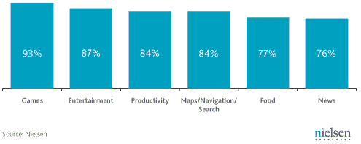

Figure : Percentage of App Downloaders who would pay for an App by category [3]

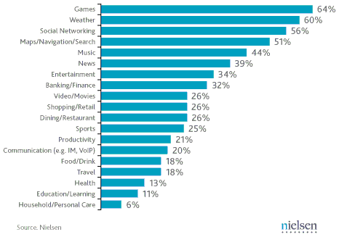

Figure : Most popular mobile app categories [3]

However mobile games are heavy and consume huge amount of memory (RAM), Storage Space, Data and most importantly Battery. This makes them kill the phone battery and reduce the talk time of the phone which results in smartphones not lasting even one full day of charge. The light casual and social games are connected to internet all the time and also cause battery drain on phones. Almost all the apps listed on Verizon’s high risk android apps [4] are Games ranging from action games to simple casual/social games. As per Verizon these apps can have serious negative effects on the device like loss of functionality, unexpected high data usage, battery drain 2 to 3 times faster than normal and security and privacy exposure. In this project we intend to study the smartphone resource consumption by games and come up with the main issues which cause battery drain.

From the industry perspective, our project will help mobile app developers to improve their games and consume smartphone resources efficiently thus increasing games usage stats and revenues even more. From a consumer point of view, users will play games and still not require to charge their phones often thus making better use of the mobile charge and the data plans.

# Approach

Our approach to achieve the goal -

## Data Collection:

To study the mobile resources consumption statistics on smartphones when playing games. For this we will gather data from multiple users and smartphones with multiple executions of several popular games. We will include popular games like Bejeweled, Farm Saga, Candy Crush Saga, Clash of Clans, Fifa, 2048, Quiz Up and collect data of their execution on many phones on various instances. We will use multiple profiling applications to get the resource consumption like ARO, Power Tutor etc.

## Analysis:

In order to analyze the resource consumption multiple profiling apps – ARO, Power Tutor. We will collate the data collected using profiling apps. Explore ways to improve game scores and information sync. Evaluate possibilities to improve communication with online web services of the games.

## Recommendation:

At the end of this project we expect to identify inefficiencies in implementation of mobile games. We also hope to come up with solutions or better implementation strategies for implementing mobile games.

# Key Challenges

## Time constraint:

One of the major constraints is limited availability of time to complete the project. To address this issue we will limit our data set focused to particular cluster of mobile gamers within students from Indiana University Bloomington. We will only consider android platform for our analysis and hope to extrapolate the date for other platforms.

## Data collection and user availability:

Since we focus on a few popular games in the current scope, finding users who play those games frequently will be a challenge. We plan to identify potential set of gamers and convince them to play these games for the purpose of our study.

## Data isolation:

Since users’ smartphone has many applications running in the background isolating the resource consumption statistics of the game will be a challenge.

To address this issue we can -

* Allot timeslots for the tests and encourage the gamers to turn off all the other applications during the tests;
* Or, collect two sets of data with and without gameplay and take the difference of the two sets.

## High bandwidth data usage collection:

A possible approach could be to acquire a SIM with unlimited data plan for the study and execute multiple runs of games on phones using the SIM.

# Timeline

## Design:

|  |  |
| --- | --- |
| Feb 13, 2015 – Feb 20, 2015: | Design  Identifying test subjects.  Initial Design, Tools and installations.  Games finalization  Hardware acquisition (SIM and phones if required) |

## Implementation:

|  |  |
| --- | --- |
| Feb 21, 2015 – Mar 20, 2015: | Implementation - Data Collection Phase |

## Evaluation:

|  |  |
| --- | --- |
| Mar 21, 2015 – Apr 10, 2015: | Evaluation – Data Analysis and Recommendation |
| Apr 11, 2015 – Apr 30, 2015: | Project Report |

# References

1. "Games Account for 16% of the Total Time Spent on Mobile Apps in the US." (comScore). Accessed February 14, 2015. http://www.factbrowser.com/facts/15662/.
2. "Mobile Game Revenue Will Reach $28.9B by 2016, up 38% from 2014." (Juniper Research). Accessed February 14, 2015. http://www.factbrowser.com/facts/15109/.
3. Schroeder, Stan. "Mobile Games Dominate Smartphone App Usage [STATS]." Accessed February 14, 2015. http://mashable.com/2011/07/07/smartphone-mobile-games/.
4. "High Risk Android™ Apps." High Risk Android Apps. Accessed February 14, 2015. http://www.verizonwireless.com/support/high-risk-android-apps/.